|  |
| --- |
| **CIVE 898** |
| Computational Problem Solving in Civil Engineering |
| Homework 1 |
|  |
| **bsoni2** |
| **9/5/2012** |

**Problem 1**

Parts a) to g) are straight forward matrix operations and are self-explanatory. However part (h) is a bit tricky one,



Solutions to matrix division are derived by using the following Left Division and Right Divisions, depending on which matrix needs to be eliminated

x = A\b is a solution to A*x = b

x = b/A is a solution to x*A = b

to calculate our problem the left division is applicable. Hence solution to **“By = w”** is given by the matrix operation of **“y= B\w”**

**Problem 2**



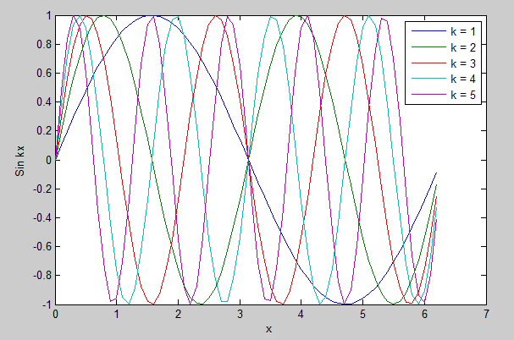

To plot the graph of the sin (Kx)function, we first defined the K as a column matrix containing values 1 thru 5. And x from 0 to 2pi on an interval of .1, then sin (Kx) is calculated and saved as a matrix Sine. There after Sine is plotted with respect to the changing values of x. As the value of **k** changes from 1 to 5 the value of **kx** increases more abruptly hence the wavelength of the sin function decreases.

**Problem 3.**



r = 2

L = 5

h = 2.r

h =0

Function Volume of a cylinder is a function of three variables radius (r), Length (L) and height of the liquid (h). We start the program with giving the function name “Volume” and the input arguments i.e. (r, L, h) in the same order. Since the value of h can vary from 0 to diameter of the cylinder (2r). We perform an **“if”** statement to check if **h > 2r,** if it is more than 2 r, it displays to the user of the function that the value of h cannot exceed the diameter. If it is less than or equal to 2r we go ahead to perform the programming functions to calculate the value of Volume for respective value of h of the liquid. This can be done in a couple of ways

1. Using Matrix operations (Volume) with a capital V
2. Using the For command (volume) with a small v

I have done the program with both the approaches. For the matrix approach, the values are all calculated and stored in matrices simultaneously and then plotted. We declare h as a matrix from 0 to h at an interval of 0.1. Calculating Volume as a matrix using the given formula

**V=[(r^2*(acos((r-h)/r)))-((r-h).*((2*r*h-h.^2).^.5))]*L**

This gives a matrix

**(r-h).**entity tells the function program to perform element operation on the (r-h) matrix with the corresponding element of the matrix obtained from (**2*r*h-h.^2).^5**

By using the For statement approach , although MATLAB is using the matrix to store and calculate the information but the values are caluculated in a loop one at a time and stored in the matrix that is called upon later to plot the graph.

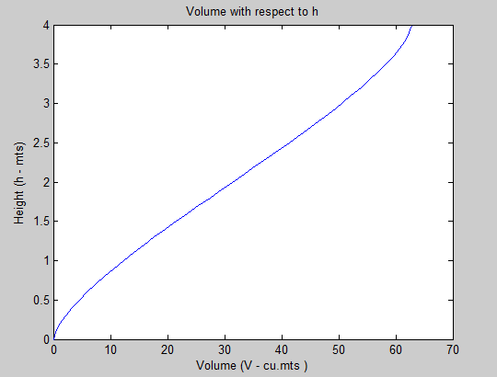

Problem 4. To convert the Cartesian coordinates to a polar coordinates we have to calculate two things r (distance from the origin) and Theta (Angle at which the point lie with the origin. r is calculated with the formula (x^2 +y^2)^(1/2) where as to calculate the angle we have to check in what quadrant it is located. For this we use a series of checks and calculate the angle using the relative formulas. Rest is explained in the flow chart given below.

(b). Using the function coordinates (x,y) we following values of r and angle were obtained

|  |  |  |  |
| --- | --- | --- | --- |
| **x** | **y** | **r** | **Angle (deg)** |
| 1 | 0 | 1 | 0 |
| 1 | 1 | 1.4142 | 45 |
| 0 | 1 | 1 | 90 |
| -1 | 1 | 1.4142 | 135 |
| -1 | 0 | 1 | 180 |
| -1 | -1 | 1.4142 | -135 |
| 0 | -1 | 1 | -90 |
| 1 | -1 | 1.4142 | -45 |
| 0 | 0 | 0 | 0 |

Problem 4 (a). Flowchart to convert Cartesian coordinates in to polar coordinates.

Calculate r=(x^2+y^2)^.5

Get x and y

**NO**

**YES**

**YES**

Angle = 270

**NO**

**NO**

**NO**

**NO**

**YES**

**YES**

**NO**

**YES**

**YES**

Angle = 0

Is y = 0

Angle = 90 degree

Is y > 0

Calculate

angle = tan^(-1) of ( y/x)*180/pi

Angle = 180

Calculate

angle = (tan^(-1) of ( y/x) +pi)*180/pi

Calculate

angle = (tan^(-1) of ( y/x) -pi)*180/pi

Is y = 0

Is y >0

Is x=0

Is x >0